P510/2

PHYSICS

Paper 2

Nov./Dec. 2020

2 hours

SERERE TOWNSHIP SECONDARY SCHOOL
MOCK EXAMINATIONS 2020

Uganda Advanced Certificate of Education

PHYSICS

Paper 2

2 hours 30 minutes

INSTRUCTIONS TO CANDIDATES

Answer five questions including at least one but not more than two from each of the sections A, B, C and D.

Mathematical tables and squared paper will be provided.

Non – programmable scientific calculators may be used.

Assume where necessary

Acceleration due to gravity,

Speed of light in a vacuum,

Electron charge,

Electron mass

Plank’s constant,

Permeability of free space,

Permeability of free space,

The constant

One electron Volt

Avogadro’s number,

Resistivity of Nichrome wire at

Specific heat capacity of water

Turn Over
SECTION A

- (a)Describe an experiment to determine the focal length of a concave lens using a convex

of known focal length. (05marks)

- A convex lens and a concave lens of focal lengths 17.5 and 15.0cm respectively are

mounted coaxially apart with the concave lens facing a distant object. Find:

(i) the final position of the image (03marks)

(ii) the magnification of the image produced by the concave lens (02marks)

- Explain why a paraboloid mirror is used in search lights instead of a concave.(03marks)

 | (d) | Describe how the angle of a prism can be measured using a spectrometer | (05marks)
 | (e) | Differentiate between chromatic and spherical aberrations | (02marks)
2. | (a) | Define the terms refraction and refractive index | (02marks)

- Derive an expression for the apparent displacement of an object when viewed normally

through a parallel sided glass block.

(05marks)

(c) (i) A glass block of refractive index is immersed in a liquid of refractive index .

A ray of light is partially reflected and refracted at the interface such that the

angle between the reflected ray and the refracted ray is 900.

Show that , where is the angle from the liquid to glass. (04marks)

- When the procedure in (i) is repeated with the liquid removed, the angle of

incidence increases by Given that , find and the angle of incidence at the liquid glass interface. (06marks)

- A point source of white light is placed at the bottom of a water tank in a dark room. The light from the source is observed obliquely at the water surface. Explain what is

observed. (03marks)

SECTION B

- (a)Use Huygen’s principles to show that the angle of incidence is equal to the angle of

reflection for light falling on a plane reflecting surface. (05marks)

- (i)Draw a ray diagram showing the path of light rays through the experimental arrangement for the determination of the wave length of light using a single slit

and bi prism. (02marks)

(ii) In a single slit and bi prism experiment a prism of refracting angle and refractive index 1.5 is used. The slit and the screen are and respectively from the bi prism. If light of wavelength is used, find the width of the fringes. (05marks)

- State one advantage of the biprism method over Young’s double slit method.

(01mark)

2

(c) Distinguish between continuous and line emission spectra.

(d) Describe one application of absorption line spectra.
(03marks)

(04marks)

- (a)Explain the terms wave length and wave front as applied to wave motion. (02marks)

(b) (i) Define the term resonance (01mark)

- Describe how you would determine the velocity of sound in air using a resonance

tube. (05marks)

- Explain with the aid of suitable diagrams the terms fundamental note and overtone as

(d)

applied to a vibrating wire fixed at both ends. (05marks) A stretched wire of length , radius and density is clamped at both ends and plucked in the middle. The fundamental note produced by the wire has the same frequency as the first overtone in a pipe of length closed at one end. (i) Sketch the standing wave pattern in the wire (01mark)

- Calculate the tension in the wave (The speed of sound along the stretched wire is

 |  |  | √ |  |  | where |  |  | is the tension in the wire and |  | the mass per unit length. Speed of
 |  |  | sound in |  |  |  |  |  |  | ). |  |  |  |  |  | (06marks)
 |  |  |  |  |  |  |  |  |  | SECTION C
5. | (a) | A circular coil of |  |  |  |  |  |  | turns, each of radius carries current .
 |  | (i) | Write an expression for magnetic flux at the centre of the coil |  |  |  |  |  |  |  |  |  |  |  |  | (01mark)
 |  | (ii) | Sketch the magnetic field pattern associated with the coil. |  |  |  |  |  |  |  |  |  |  |  |  | (02marks)
 |  | (iii) | Describe a simple experiment to verify the expression in (i) when
 |  |  |  | and |  |  | are constant. |  |  |  |  |  |  |  |  | (06marks)
 | (b) | (i) | What is meant by magnetic moment of a current carrying coil? |  |  |  |  |  |  |  |  |  |  |  |  | (02marks)
 |  | (ii) | A circular coil of |  |  |  |  |  |  | turns each of radius | is suspended with its plane along
 |  |  | a uniform magnetic field of flux density |  |  |  |  |  |  |  | . Find the initial torque on the coil
 |  |  | when a current of |  |  |  |  |  |  | is passed through it. |  |  |  |  |  | (03marks)
 | (c)
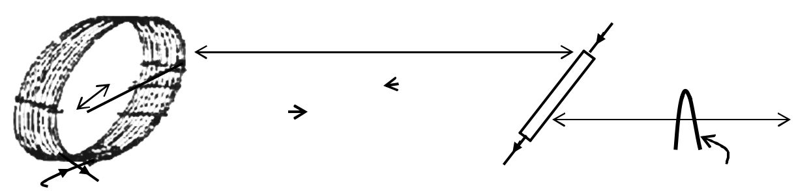

Fig. 1
Rider

A rectangular loop of wire WXYZ is balanced horizontally so that the length XY is at the

centre of a circular coil of turns of mean radius 10.0cm as shown in figure 1.

When a current I is passed through XY and the circular coil, a rider of mass

has to be placed at a distance of from WZ to restore balance.

Find the value of the current (06marks)

3

6. | (a) | (i) | Derive the relationship between peak value and root-mean square value of a
 |  |  | sinusoidal current. | (04marks)

- Calculate the root mean square value of an alternating current which dissipates energy in a heating coil immersed in a liquid in a calorimeter at two times the rate

(b)
at which direct current of would if passed through the same coil under the

same conditions. (03marks)

A source of sinusoidal voltage of amptitude and frequency is connected across a

capacitor of capacitance .

(i) Without using any formula explain why a current apparently flows through the capacitor and is out of phase with the voltage. (03marks)

  - Find the amplitude of the current which flows and sketch a graph of the amplitude against frequency if the resistance of the connecting wire is negligible. (04marks)

- Draw a labelled diagram of a moving coil galvanometer and explain why it cannot be

used to measure an alternating current. (05marks)

- (a)What is meant by:

- mutual induction

(ii) self induction

(02marks)

(b)

Describe an experiment to demonstrate mutual induction.

(03marks)

(c)
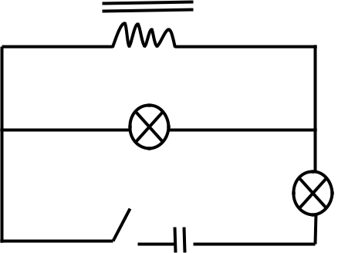

 |  |  | Fig. |  | 2
 | Bulbs | and | rated | , | are connected to an inductor, |  |  | of large inductance as
 | shown in figure . Explain what is observed when;
 | (i) | Switch | is first closed |  |  |  |  |  | (04marks)
 | (ii) | Switch | is opened |  |  |  |  |  | (02marks)
(d) | (i) | Describe briefly the action of a transformer |  |  |  |  |  |  | (04marks)
 | (ii) | Describe briefly four causes of inefficiency in a transformer |  |  |  |  |  |  | (02marks)
(e) | A transformer is designed to work on a |  |  |  |  | , | supply. It has |  | turns in the
 | primary and |  | turns in the secondary and its efficiency is |  |  |  |  | Calculate the current
 | in the secondary coil. |  |  |  |  |  |  |  | (04marks)

4

 |  |  | SECTION D
8. | (a)(i) | Draw the circuit diagram of the metre bridge and use it to derive the condition for
 |  | balance. | (06marks)

- Explain why the metre bridge is unsuitable for comparison of low resistances. (02marks)

(iii) When resistors of resistances and are connected respectively in the left

and right hand gaps of a metrebridge a balance point is obtained at a point a

distance of from the left hand end of the bridge wire. On interchanging

the resistors a balance point is obtained at a point from the left hand end.

The resistance of the uniform wire of the metrebridge is . Calculate the end

errors. (04marks)
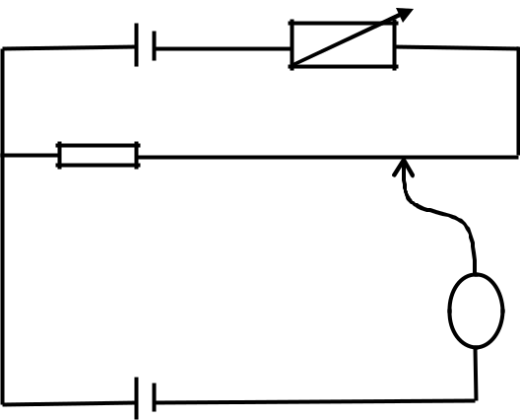

(b)

 |  |  | Fig. 3
 |  | In figure 3 above is a driver cell of e.m.f. |  |  |  | and negligible internal resistance. |  | is
 |  | standard cell of e.m.f. |  | and | is a uniform wire of resistance |  | and length
 |  |  | . The galvanometer | shows no deflection when |  |  | . Find:
 |  | (i) | the current flowing in the driver circuit |  |  |  | (02marks)
 |  | (ii) | the resistance of the rheostat |  |  |  | (04marks)
 |  | (iii) | the e.m.f of a thermo | couple which is balanced by a length of |  |  | of the
 |  |  | slide wire |  |  |  | (02marks)
9. | (a) | (i)
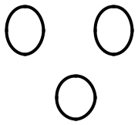

Fig. 4

In figure 4, A, B and C are point charges of equal magnitudes.
- Sketch the field lines due to the charges and show the position of the neutral

point. (03marks)

(ii) Explain why a charged material attracts an uncharged conductor

(03marks)

5

- With the aid of a labeled diagram describe how a large electric potential can be built up
using a Van der Graaf generator. (07marks)
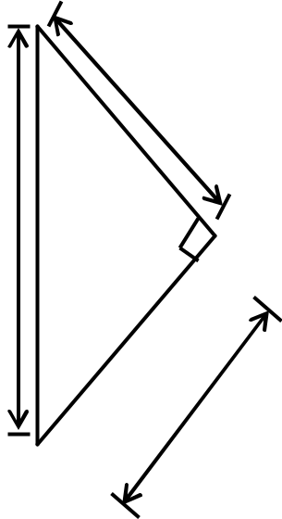

Fig. 5

 |  | Two point charges of | and | are placed in air at points and | as shown
 |  | in figure 5. Determine the electric field intensity at . |  |  | (07marks)
10. | (a) | What is meant by capacitance of a capacitor? |  |  | (01mark)

- Describe an experiment you would carry out to verify that the capacitance of a parallel

plate capacitor is proportional to , where is the plate separation, is the area of

overlap of the plates and is the permittivity of the medium between the plates (06marks)
- (i) Derive an expression for the effective capacitance of three capacitors of capacitances
C₁ , C₂ and C₃ connected in parallel. (03marks)
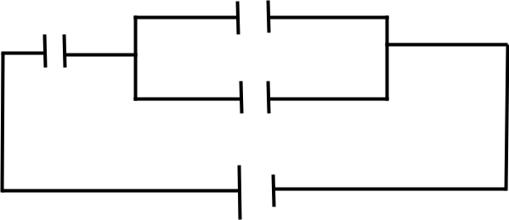

(ii)

Fig. 6

A battery of e.m.f is connected across a system of capacitors as shown in figure 6. Calculate the total energy stored in the capacitors. (04marks)

(d) (i)
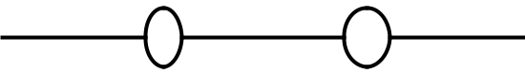

 | Fig. 7
 | Figure 7 shows two charges ⁺ and – | placed along a line | . Sketch the
 | variation of electric potential along | . |  | (02marks)
(ii) | Explain with the aid of a diagram the term electrostatic shielding |  |  | (04marks)
 | 6 |  |  | END

